Linear quadratic gaussian regulator for the nonlinear observer based control of a dynamic base inverted pendulum

K. Mirza, SVKM’S NMIMS

The inverted pendulum is a non-linear control problem permanently tending towards instability. The main aim of this study is to design a controller capable enough to work within the given conditions while also keeping the pendulum erect given the impulsive movement of the cart. This paper talks about a novel adaptive control mechanism employing a Kalman filter for a mobile inverted pendulum system (MIPS). In the former half of the paper, the mathematical modelling of the dynamical system along with the design of a Linear Quadratic Regulator (LQR) is presented. This is then followed by a Linear Quadratic Gaussian (LQG) controller to improve upon the prior’s shortcomings. The simulation is done through Simulink and results show that both controllers are capable of managing the multiple output model. However, data from simulations clearly showed that an LQG controller is a better choice.

Nomenclature:
(M) mass of the cart
(m) mass of the pendulum
(b) coefficient of friction for cart
(l) length of pendulum
(I) mass moment of inertia of the pendulum
(F) force applied to the cart
(x) cart position coordinate
(u) cart velocity
($X_{G}$) X co-ordinate of Instantaneous centre of gravity of point mass
($X_{G}$) Y co-ordinate of Instantaneous centre of gravity of point mass
($θ$) pendulum angle from vertical (down)
($Φ$) angle of deviation

1. Introduction
The inverted pendulum system (IPS) is a typical nonlinear control problem suitable for studying various aspects of a under actuated system. Most of the realistic control systems are non-linear in nature. Controlling such a dynamic system is a challenging task. The control mechanism adopted here can also be used in various military and robotics, chaotic systems and aerospace applications such as attitude control of launch vehicles and missiles. [1-3] The implementation of a controller for such a system has been of interest to the control engineering community for quite a while due to it’s complex nature for creating a benchmark to compare different control methods and various procedures for their design. Due to it’s importance, this was the choice of dynamic system selected. There are various issues at hand with such a system, the biggest being its inertia. Several methods have been adopted to control such a system. In [1], [4]-[9] many different kinds of control schemes are presented. Shirren and Patel [6] used a basic LQR + PID controller was used to control the nonlinear system, a common technique for such dynamic situations. The clear drawback in this case was the settling time which appears to be about 5 seconds. Effort was made in this paper to address and provide a solution to this issue. Babushanmugham et.al [7] employed Particle Swarm Optimisation (PSO) with Genetic Algorithm and SMC, but PSO-SMC responses proved to show better results. In [8], a comparison is made between a Fuzzy controller and a PID controller, and a conclusion is drawn that a simple PID controller would fail to provide the required stability. The main aim of this study is to design a controller capable enough to work within the given conditions while also keeping the pendulum erect given the impulsive movement of the cart. The system in question considers a cart capable of bidirectional linear motion along the X-axis with an inverted pendulum attached to it via a hinge allowed to oscillate in the X-Y plane. The design parameters are as Table (1):
Table (1): Design parameters of the IPS
Mass of the Cart | 0.5 kg
Mass of the Pendulum | 0.2 kg
Length of the Pendulum | 0.3 m
Co-efficient of static friction between Cart and linear rail | 0.1
Pendulum’s Moment of Inertia | 0.006 $kgm^{2}$
Max settling time | 3 s
Maximum Angular Deviation of the Pendulum | 0.5 rad
2.Modelling
By summing the forces in the horizontal direction acting on the cart we obtain the first equation of motion.
 | $$M\ddot{x}+b\dot{x}$$ | (1)
Summing the forces on the pendulum
 | $$N=m\dot{x}+ml\ddot{θ}cosθ-ml{\dot{θ}}^{2}sinθ$$ | (2)
By (2) and (1) the first equation of motion is obtained
 | $$\left(M+m\right)\ddot{x}+b\dot{x}+ml\ddot{θ}cosθ-ml{\dot{θ}}^{2}sinθ=F$$ | (3)
By solving about the axis perpendicular to the pendulum
 | $$Psinθ+Ncosθ-mgsinθ=ml\ddot{θ}+m\ddot{x}cosθ$$ | (4)
Summing the moments about the centroid of the pendulum,
 | $$-Plsinθ-Nlcosθ=I\ddot{θ}$$ | (5)
From (4) and (5)
 | $$\left(I+ml^{2}\right)\ddot{θ}+mglsinθ=-ml\ddot{x}cosθ$$ | (6)
The set of equations of motion (3) and (6) are nonlinear and need to be linearized. It is evident that the output is not proportional to the change in input and for solving such nonlinear equations we employ the use of standard state space forms of these two equations. Linearization of the system about the central upright position of the pendulum is done and a reference state is defined where no external force is applied yet. Thus, cart velocity and position are considered to be zero. Here we assume that the system stays within a region cantered at $θ=π$. On presuming $(Φ)$ a small deviation from the central position, we employ the following approximations:
 | $$cosθ=\cos\left(π+φ\right)≈1$$ | (7)
 | $$sinθ=\sin\left(π+φ\right)≈-φ$$ | (8)
 | $$\dot{θ^{2}}={\dot{φ}}^{2}≈0$$ | (9)
Substituting (7), (8) and (9) into (3) and (6) we arrive at a linearized form of the equations of motion
 | $$\left(M+m\right)\ddot{x}+b\dot{x}-ml\ddot{φ}=F$$ | (10)
 | $$\left(I+ml^{2}\right)\ddot{φ}-mglφ=ml\ddot{x}$$ | (11)
Taking the Laplace transform of (10) and (11)
 | $$\left(M+m\right)X\left(s\right)s^{2}+bX\left(s\right)s-mlΦ\left(s\right)s^{2}=U(s)$$ | (12)
 | $$\left(I+ml^{2}\right)Φ\left(s\right)s^{2}+bX\left(s\right)s-mlΦ\left(s\right)=mlX(s)s^{2}$$ | (13)
We define the output as angle of deviation ($Φ$) and the input to the system as U(s)
Re-arranging (13)
 | $$X\left(s\right)=\left[\frac{I+ml^{2}}{ml}-\frac{g}{s^{2}}\right]Φ(s)$$ | (14)
Substituting (14) in (12)
 | $$\left(M+m\right)\left[\frac{I+ml^{2}}{ml}-\frac{g}{s^{2}}\right]Φ\left(s\right)s^{2}+b\left[\frac{I+ml^{2}}{ml}-\frac{g}{s^{2}}\right]Φ\left(s\right)s-mlΦ\left(s\right)s^{2}=U(s)$$ | (15)
Thus, we obtain a fourth order transfer function as:
 | $$\frac{Φ\left(s\right)}{U\left(s\right)}=\frac{\left(\frac{\left(I+ml^{2}\right)s^{2}-gml}{q}\right)}{s^{4}+\left(\frac{b\left(I+ml^{2}\right)}{q}\right)s^{3}-\left(\frac{\left(M+m\right)mgl}{q}\right)s^{2}-\left(\frac{bmgl}{q}\right)s}$$ | (16)

Where $q=[\left(M+m\right)\left(I+ml^{2}\right)-{(ml)}^{2}]$
we create a general linear state space representation for our system
 | $$\dot{x}\left(t\right)=A\left(t\right)x\left(t\right)+B(t)u(t)$$ | (17)
 | $$y\left(t\right)=C\left(t\right)+D(t)u(t)$$ | (18)
The state variables are defined as
 | $$x_{1}=x, x_{2}= \dot{x}={\dot{x}}_{1}, { x}_{3}=Φ, x_{4}=\dot{Φ}={\dot{x}}_{3}$$ | (19)
For creating the state space representation we define the most general representation of a linear system and using equations (10) and (11)
$\left[\begin{matrix}\dot{x} \\ \begin{matrix}\ddot{x} \\ \begin{matrix}\dot{ϕ} \\ \ddot{ϕ}\end{matrix}\end{matrix}\end{matrix}\right]=\left[\begin{matrix}\begin{matrix}0 \\ \begin{matrix}0 \\ \begin{matrix}0 \\ 0\end{matrix}\end{matrix}\end{matrix} & \begin{matrix}\begin{matrix}1 \\ \begin{matrix}\frac{-\left(I+ml^{2}\right)b}{I\left(M+m\right)+Mml^{2}} \\ \begin{matrix}0 \\ \frac{-mlb}{I\left(M+m\right)+Mml^{2}}\end{matrix}\end{matrix}\end{matrix} & \begin{matrix}\begin{matrix}0 \\ \begin{matrix}\frac{m^{2}gl^{2}}{I\left(M+m\right)+Mml^{2}} \\ \begin{matrix}0 \\ \frac{mgl\left(M+m\right)}{I\left(M+m\right)+Mml^{2}}\end{matrix}\end{matrix}\end{matrix} & \begin{matrix}0 \\ \begin{matrix}0 \\ \begin{matrix}1 \\ 0\end{matrix}\end{matrix}\end{matrix}\end{matrix}\end{matrix}\end{matrix}\right]\left[\begin{matrix}x \\ \begin{matrix}\dot{x} \\ \begin{matrix}ϕ \\ \dot{ϕ}\end{matrix}\end{matrix}\end{matrix}\right]+\left[\begin{matrix}0 \\ \begin{matrix}\frac{I+ml^{2}}{I\left(M+m\right)+Mml^{2}} \\ \begin{matrix}0 \\ \frac{ml}{I\left(M+m\right)+Mml^{2}}\end{matrix}\end{matrix}\end{matrix}\right]$ (20)
 | $$y=\left[\begin{matrix}\begin{matrix}1 \\ 0\end{matrix} & \begin{matrix}\begin{matrix}0 \\ 0\end{matrix} & \begin{matrix}\begin{matrix}0 \\ 1\end{matrix} & \begin{matrix}0 \\ 0\end{matrix}\end{matrix}\end{matrix}\end{matrix}\right]\left[\begin{matrix}x \\ \begin{matrix}\dot{x} \\ \begin{matrix}ϕ \\ \dot{ϕ}\end{matrix}\end{matrix}\end{matrix}\right]+\left[\begin{matrix}0 \\ 0\end{matrix}\right]u$$ | (21)
Putting in the aforementioned values we obtain the matrices as
 | $$A=\left[\begin{matrix}0 & 1 & \begin{matrix}0 & 0\end{matrix} \\ 0 & -0.1818 & \begin{matrix}2.6727 & 0\end{matrix} \\ \begin{matrix}0 \\ 0\end{matrix} & \begin{matrix}0 \\ -0.4545\end{matrix} & \begin{matrix}\begin{matrix}0 \\ 31.1818\end{matrix} & \begin{matrix}1 \\ 0\end{matrix}\end{matrix}\end{matrix}\right]; B=\left[\begin{matrix}0 \\ \begin{matrix}1.8182 \\ \begin{matrix}0 \\ 4.5455\end{matrix}\end{matrix}\end{matrix}\right]$$ | (20)
 | $$C=\left[\begin{matrix}\begin{matrix}1 \\ 0\end{matrix} & \begin{matrix}\begin{matrix}0 \\ 0\end{matrix} & \begin{matrix}\begin{matrix}0 \\ 1\end{matrix} & \begin{matrix}0 \\ 0\end{matrix}\end{matrix}\end{matrix}\end{matrix}\right]; D=\left[\begin{matrix}0 \\ 0\end{matrix}\right]$$ | (21)
To observe the preliminary stability of our system, a pole-zero plot is created for the previously derived transfer function. Poles are found at 0, -0.143, -5.6 and 5.57. It is observed that one of the poles lies to the right-hand side of the Y-axis. Thus, we can assume that such an independent open loop system without a controller would prove to be unstable.
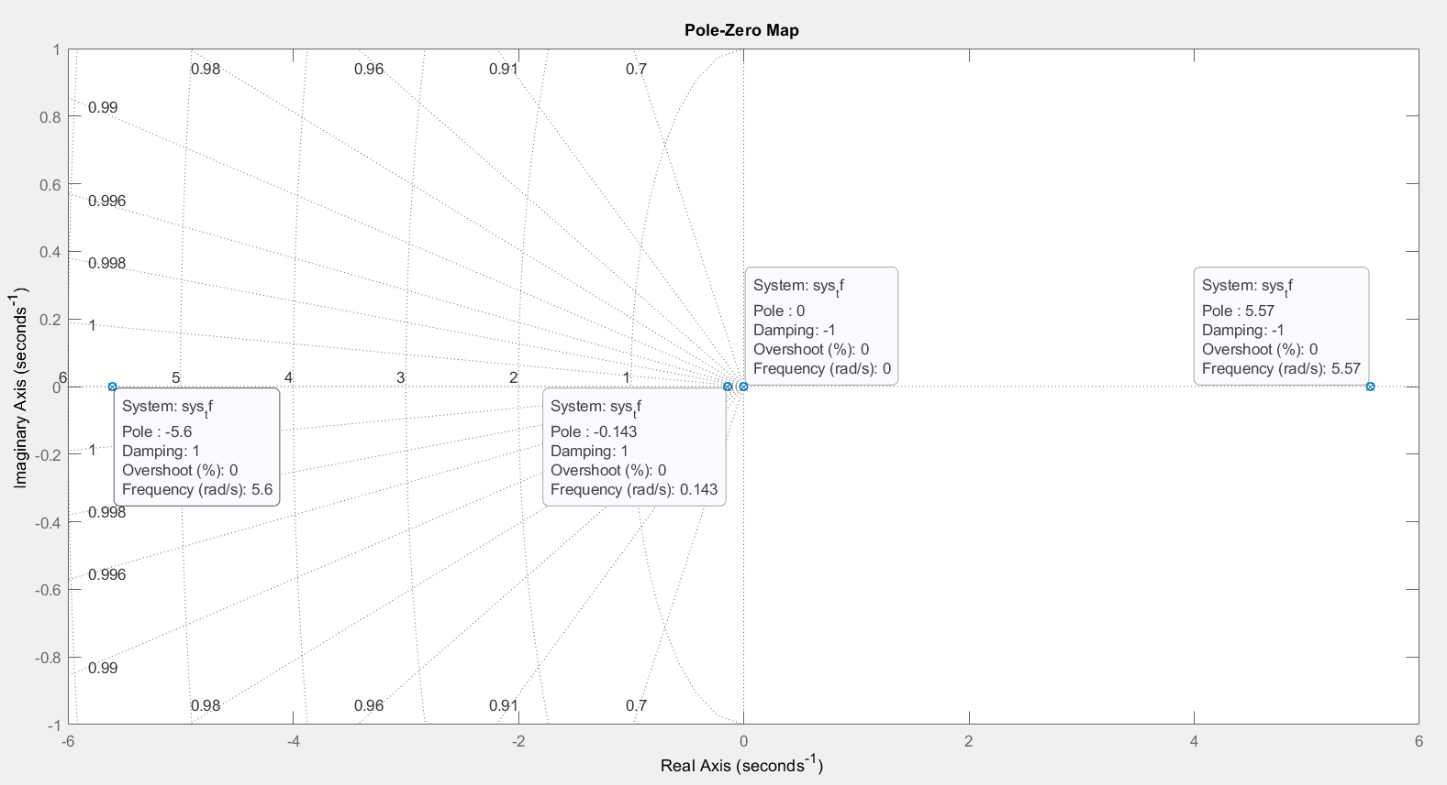
Fig(1): Pole-Zero plot for equation (16)
By providing an impulse and a step response to our open system, we can justify the above assumption (Fig(2) and Fig(3)). It is observed that the amplitude of the open system is increasing exponentially.
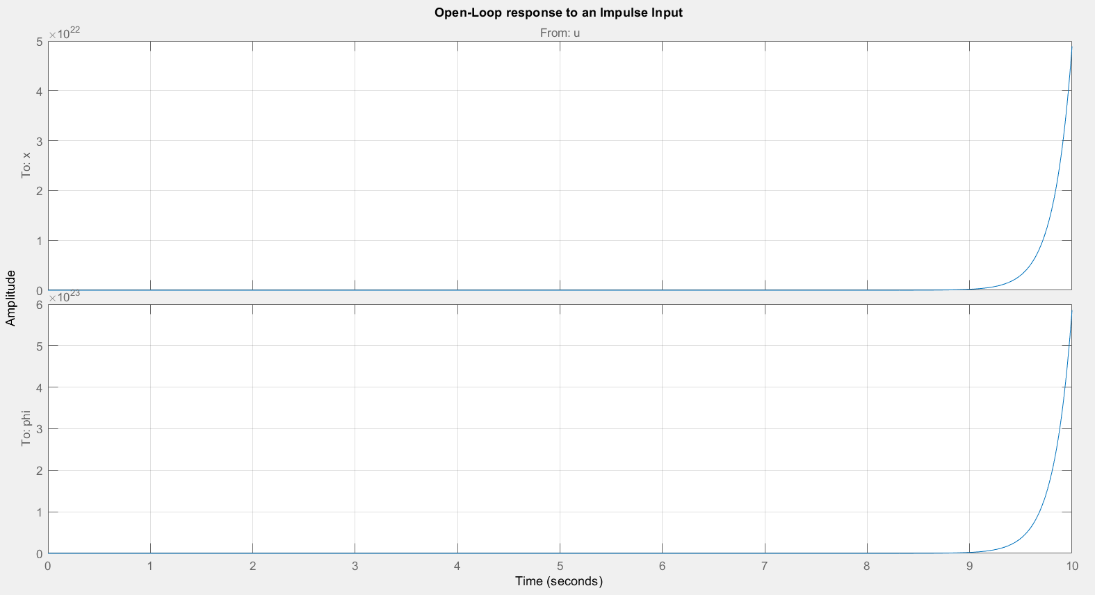
Fig(2): Open loop response to an Impulse Input

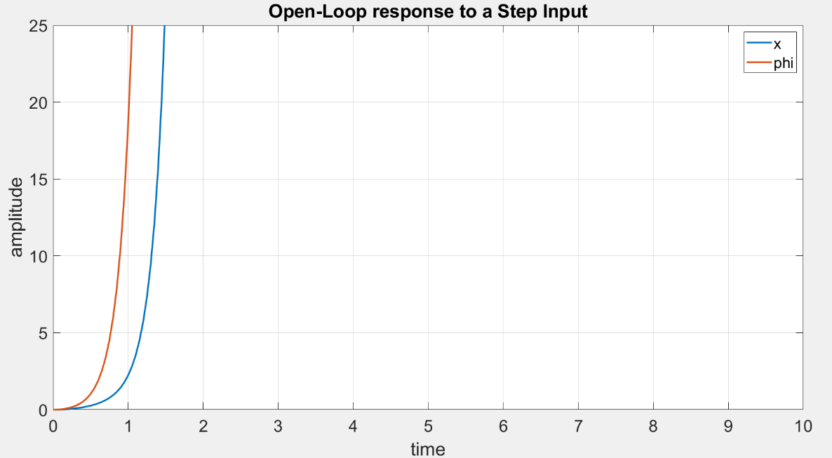
Fig(3): Open loop response to a Step Input
3. Optimal control through LQR controller
Optimal control can be defined as the process of determining state trajectories for a system which varies with time so as to minimize the costs and maximize the performance [10]. The main objective here is to strike a balance between the physical constraints and the performance criterion. Hence our requirement is to develop a controller which would cause a dynamical system to reach a fixed target with the given physical limitations. A Linear Quadratic Regulator (LQR) is one such optimal control method which provides a robust output while considering states of the unstable system while taking into account the states of the dynamical system [10], [11]. From previously defined (17), the linear state space equation [16] can be written as
 | $$\dot{x}=Ax+Bu$$ | (22)
Where $x={[\begin{matrix}x & \begin{matrix}\dot{x} & \begin{matrix}ϕ & \dot{ϕ}\end{matrix}\end{matrix}\end{matrix}]}^{T}$
Given that the feedback control $u=-Kx$, (22) can be re-arranged as
 | $$\dot{x}=(A-BK)x$$ | (23)
Here $K$ is obtained from the minimization of the cost function (24)
 | $$J=\int{(x^{T}Qx+u^{T}Ru)}$$ | (24)
 | $$K=R^{-1}B^{T}P$$ | (25)
$Q$ is defined as a semi-definitive symmetric constant matrix and $R$ is a positive definitive symmetric constant matrix in (24) and $P$ in (25) is also a positive definitive symmetric constant matrix derived from algebraic Riccati Equation (ARE) (26).
 | $$A^{T}P+PA-P^{2}B^{T+1}R^{-1}+Q=0$$ | (26)
On further examination of our system we find that it is controllable and observable though equations (27) and (28).
 | $$C=[\begin{matrix}B & \begin{matrix}AB & \begin{matrix}A^{2}B & \begin{matrix}⋯ & A^{n-1}B\end{matrix}\end{matrix}\end{matrix}\end{matrix}]$$ | (27)
 | $$O=\left[\begin{matrix}C \\ \begin{matrix}CA \\ \begin{matrix}CA^{2} \\ \begin{matrix}⋮ \\ CA^{n-1}\end{matrix}\end{matrix}\end{matrix}\end{matrix}\right]$$ | (28)
3.1 Designing the controller
To find the feedback gain vector K, we use the linear quadratic regulation method. The R and Q parameters which we select will define the balance between the relative importance of the control effort and the deviation from the central position of the pendulum. For the initial case, we will assume $R=1$ and $Q=C^{'}C$. Here equal importance on both control parameters (cart’ velocity) and output variables ($ϕ$).
 | $$Q=C'C=\left[\begin{matrix}1 & 0 & \begin{matrix}0 & 0\end{matrix} \\ 0 & 0 & \begin{matrix}0 & 0\end{matrix} \\ \begin{matrix}0 \\ 0\end{matrix} & \begin{matrix}0 \\ 0\end{matrix} & \begin{matrix}\begin{matrix}1 & 0\end{matrix} \\ \begin{matrix}0 & 0\end{matrix}\end{matrix}\end{matrix}\right]$$ | (29)
Here Q (1,1) and Q (3,3) is the weight of the cart’s position and the pendulum’s angle respectively. What matters to us is the relative difference between the values of Q and R and not their absolute values. For our problem we set Q(1,1) to 5000 and Q(3,3) to 100.
 | $$Q=\left[\begin{matrix}5000 & 0 & \begin{matrix}0 & 0\end{matrix} \\ 0 & 0 & \begin{matrix}0 & 0\end{matrix} \\ \begin{matrix}0 \\ 0\end{matrix} & \begin{matrix}0 \\ 0\end{matrix} & \begin{matrix}\begin{matrix}100 & 0\end{matrix} \\ \begin{matrix}0 & 0\end{matrix}\end{matrix}\end{matrix}\right]$$ | (30)
While it may appear drastic to compromise the pendulum deviation angle for cart’s position control, it is found that the settling time for the pendulum is still within our design parameters. Such a configuration yields a gain matrix $K=[\begin{matrix}-223.6068 & \begin{matrix}-107.1604 & \begin{matrix}258.0306 & 51.4370\end{matrix}\end{matrix}\end{matrix}]$. From Fig (4) it is evident that a steady state error exists in the cart’s position which can be eliminated by changing the reference input signal itself. In the system described, all the state variables are fed back into the controller thus a need arises to find a constant value which will be added to our feedback after multiplying it with the feedback gain array K. This can be accomplished by adding a pre-compensating or a scaling constant to our reference denoted by $K_{ref}$. For our case, $K_{ref}$ is calculated to be -223.6068 using the ‘rscale’ algorithm [17]. Fig (5) shows perfect behaviour as expected after adding the scaling parameter to the reference input.
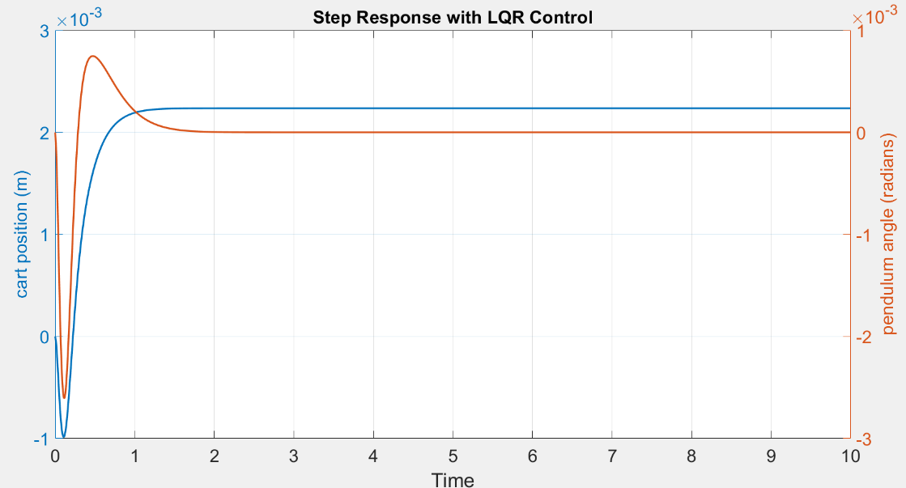
Fig (4): Step response with a simple LQR

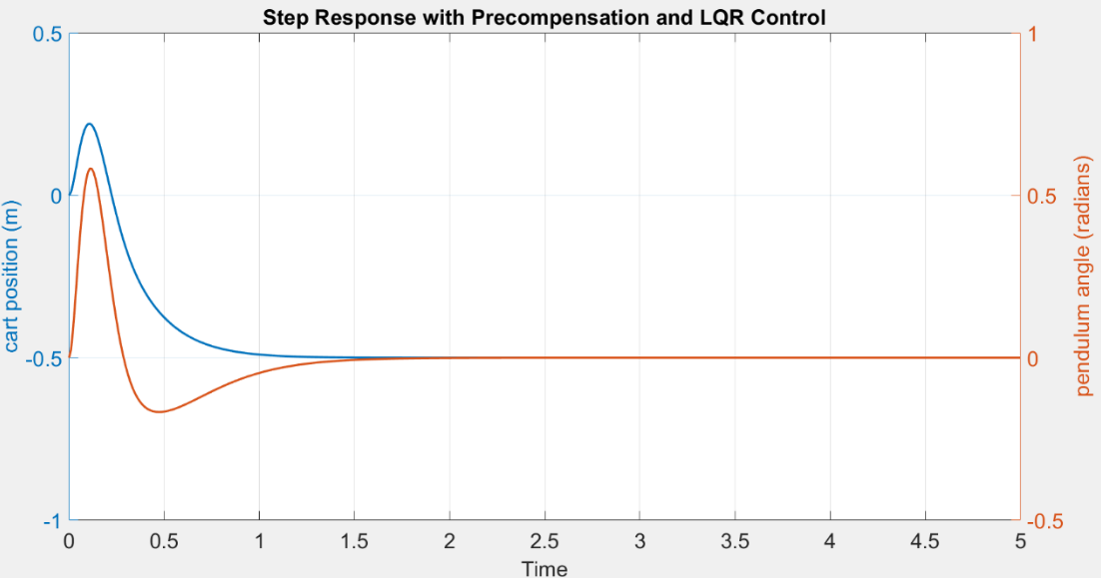
Fig (5): Step response with $K_{ref}$ applied
3.2 Designing an observer based control
An observer based controller comprises of a real time simulation making use of a correction term along with same input as the plant (31) [12]. L is the observer gain matrix and $\hat{y}$ is an estimate of the plant’s output. The observer gain matrix is used to correct the state estimate based on the difference between the actual and estimated output. It is required that the observer poles be faster than the controller poles so as to make the state estimate converge faster. The controller poles are found to be (32).
 | $$δ\hat{x}=A\dot{x}+Bu-L(y-\hat{y})$$ | (31)
 | $$p_{C}=\left[\begin{matrix}-14.8355+14.5151i \\ \begin{matrix}-14.8355-14.5151i \\ \begin{matrix}-4.7391+0.8146i \\ -4.7391-0.8146i\end{matrix}\end{matrix}\end{matrix}\right]$$ | (32)
By placing the estimator poles at a higher value than our slowest pole (-4.7391), we can obtain the estimator gain matrix (K_{e}) in a similar algorithm developed for finding feedback gain (K) stated previously and then applying a step input (Fig 6), a stable system is created using both ($Φ$) and $(x)$
 | $$K_{e}=\left[\begin{matrix}\begin{matrix}82.6415 \\ \begin{matrix}1.7002 \\ \begin{matrix}-1.4865 \\ -77.0093\end{matrix}\end{matrix}\end{matrix} & \begin{matrix}-1.0371 \\ \begin{matrix}-40.0023 \\ \begin{matrix}83.3575 \\ 1.7504\end{matrix}\end{matrix}\end{matrix}\end{matrix}\right]$$ | (33)

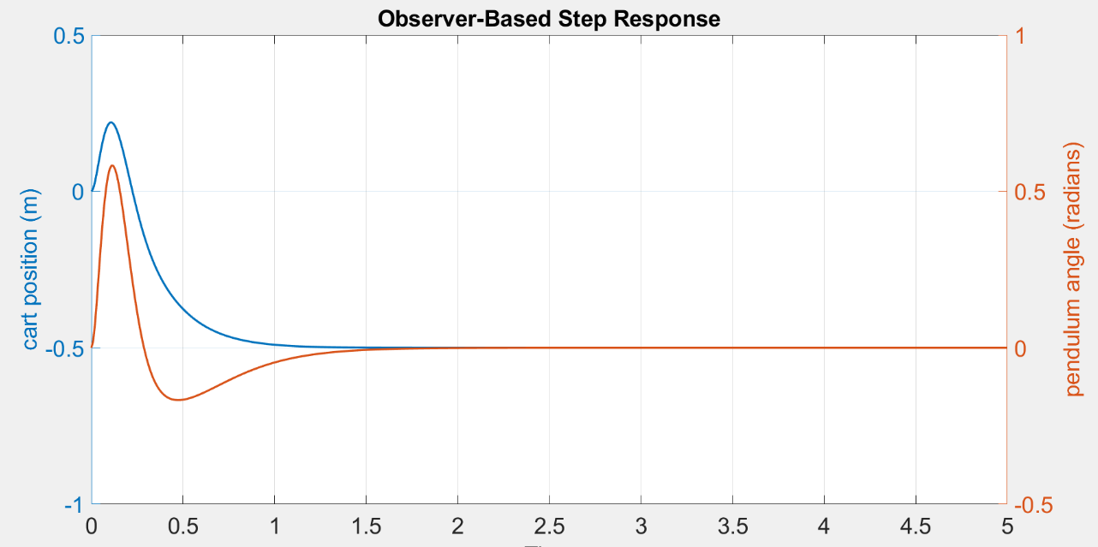
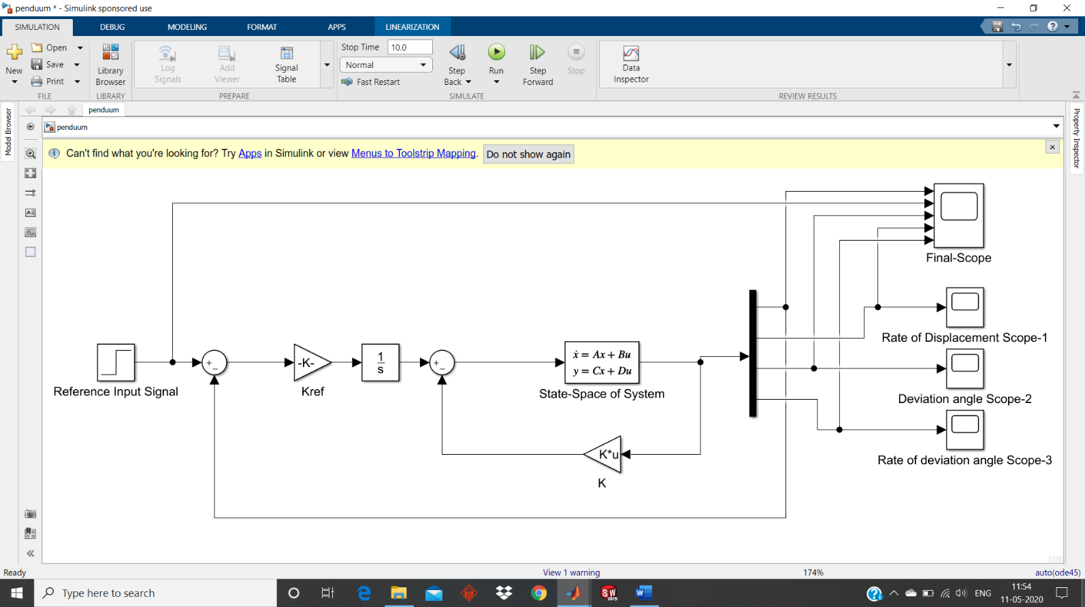
Fig (6): Step Response with Observer- Based Feedback control
Fig (7): Designing the system in Simulink, with full state feedback

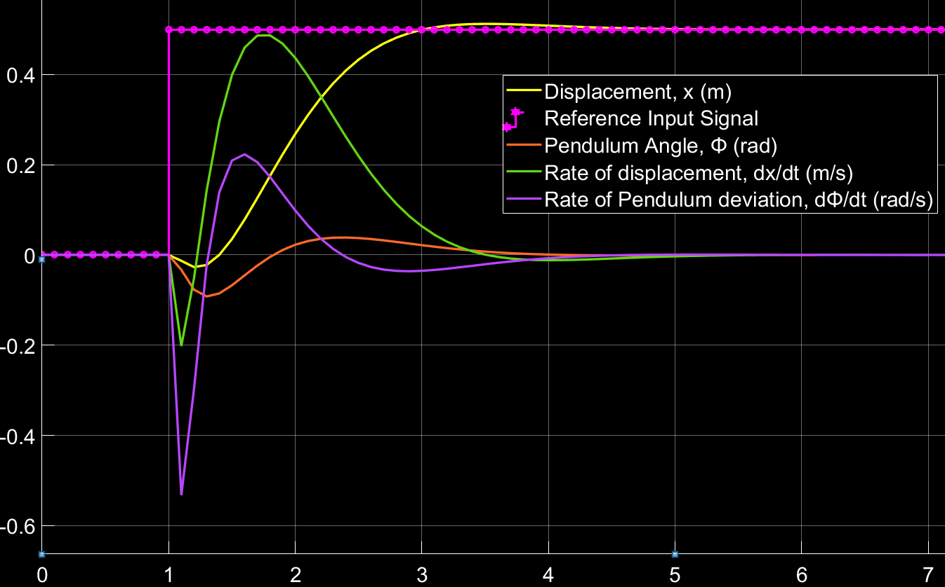
Fig (8): Unit pulse reponse of the LQG controller
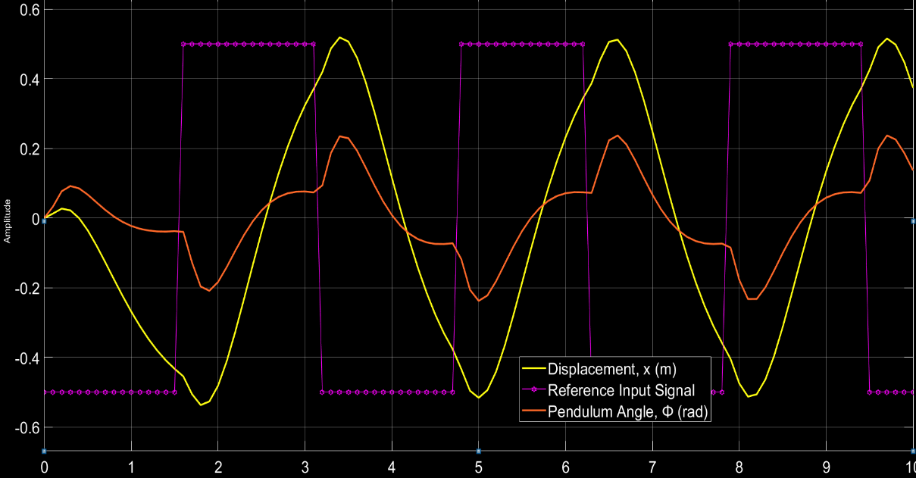
Fig (9): Continuous pulse response of the LQG controller

4. Linear Quadratic Gaussian Controller
A Linear Quadratic gaussian controller (LQG) is in essence, a LQR controller combined with a Kalman filter. An LQG controller is as dynamic as the system it control. The schematic of the LQG controller is depicted in fig(). They are applicable to linear time-variant as well as time-invariant systems [13], [14]. The separation principal states that the state estimator and the state feedback are independent of each other. A changed form of (22), (23) and (24) would now be described by:
 | $$\dot{x}\left(t\right)=A\left(t\right)x\left(t\right)+B\left(t\right)u\left(t\right)+v(t)$$ | (34)
 | $$y\left(t\right)=C\left(t\right)x\left(t\right)+w(t)$$ | (35)
 | $$\dot{\hat{x}}=\left(A-LC-BK\right)\hat{x}+Ly$$ | (36)
 | $$J=Ε[x^{T}Fx\left(T\right) + \int_{0}^{T}{x^{T}\left(t\right)Q\left(t\right)x\left(t\right)+u^{T}\left(t\right)R\left(t\right)\left(t\right) dt}]$$ | (37)
Where $y(t)$ resembles the vector of available outputs for feedback, L is the Kalman gain matrix, $v\left(t\right)$ and $w(t)$ are the white gaussian noise affecting the system and E is the expected value. We use our previously found value of $K=[\begin{matrix}-223.6068 & \begin{matrix}-107.1604 & \begin{matrix}258.0306 & 51.4370\end{matrix}\end{matrix} ]\end{matrix}$ directly in the new controller design. A Kalman filter is basically a set of equations which are used for minimizing the estimated error when the variables are linearly transformed provided that some pre-requisite conditions are met [15]. The Kalman gain is given by
 | $$L\left(t\right)=S_{e}(t)C^{T}R^{-1}$$ | (38)
 | $$S_{e}=Ε[{\left(x\left(t\right)-\hat{x}\left(t\right)\right)}^{T}(x\left(t\right)-\hat{x}\left(t\right))]$$ | (39)
To find the Kalman gain matrix, the MATLAB function ‘kalman’ was used and was found to be
 | $$L=\left[\begin{matrix}\begin{matrix}10.8148 \\ \begin{matrix}8.4945 \\ \begin{matrix}0.1679 \\ 0.6966\end{matrix}\end{matrix}\end{matrix} & \begin{matrix}0.1679 \\ \begin{matrix}3.6518 \\ \begin{matrix}15.0779 \\ 63.6857\end{matrix}\end{matrix}\end{matrix}\end{matrix}\right]$$ | (40)
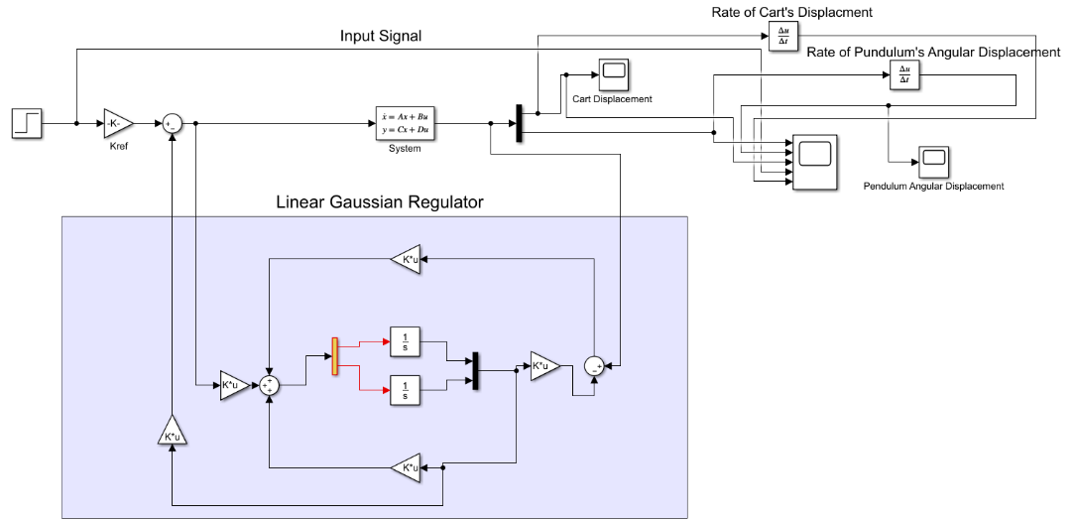
Fig (10): Simulink Diagram of an LQG controller
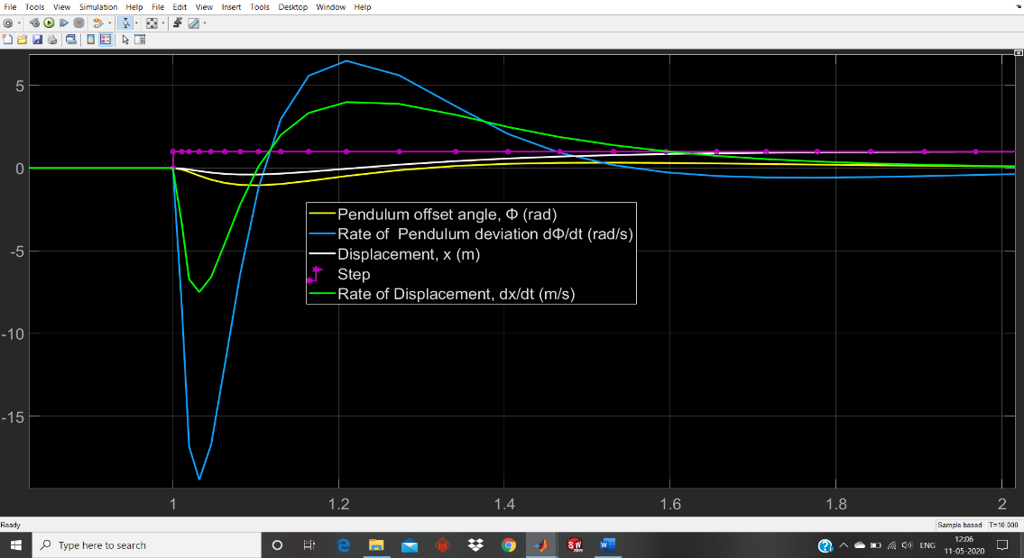
Fig (11): Simulink output for a Unit Pulse
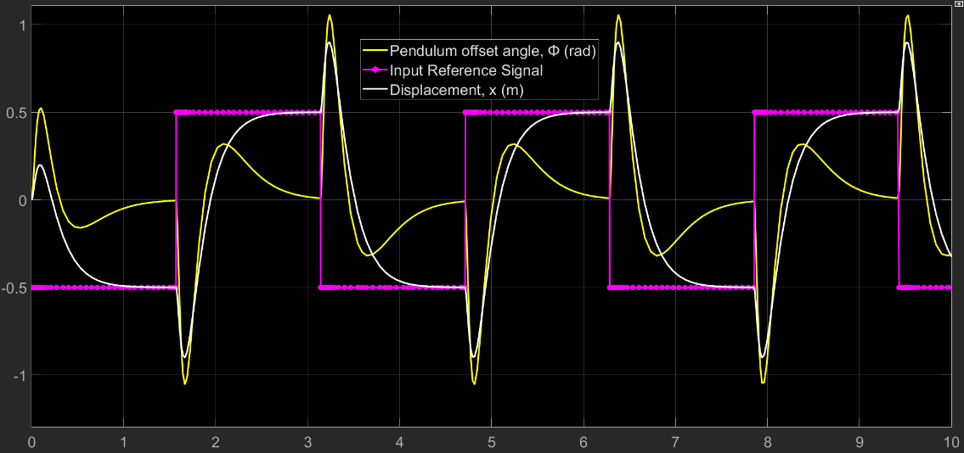
Fig (12): Simulink output for a Continuous Pulse
5. Conclusion:
From Fig (8) and Fig(11) a significant drop is the settling time can be seen (from $≈3$ to 1.6), hence proving that a LQR controller is more suitable for such the system in question in terms of accuracy. However, a huge jump is noticed in in the rate of displacement and rate of angular deviation of the pendulum. There might be circumstances where the hardware does not support such high rates and may cause malfunctioning of the entire system itself. On the other hand, while the LQR controller is definitely slower in response, it does relax the rate of change significantly.
Refer
[1] Prasad, Lal Bahadur, Barjeev Tyagi, and Hari Om Gupta. "Optimal control of nonlinear inverted pendulum dynamical system with disturbance input using PID controller & LQR." 2011 IEEE International Conference on Control System, Computing and Engineering. IEEE, 2011.
[2] K. Ogata. Modern Control Engineering, 4th ed., New Delhi: Pearson Education (Singapore) Pvt. Ltd., 2005.

[3] Isidori, Alberto, ed. Nonlinear Control Systems Design 1989: Selected Papers from the IFAC Symposium, Capri, Italy, 14-16 June 1989. Elsevier, 2014.

[4] Huang, Cheng-Hao, Wen-June Wang, and Chih-Hui Chiu. "Design and implementation of fuzzy control on a two-wheel inverted pendulum." IEEE Transactions on Industrial Electronics 58.7 (2010): 2988-3001.

[5] Eizadiyan, Mohammad Ali, and Majid Naseriyan. "CONTROL OF INVERTED PENDULUM CART SYSTEM BY USE OF PID CONTROLLER." Science International 27.2 pp. 1063-1068, March 2015

[6] Sonone, Shireen S., and N. V. Patel. "LQR controller design for stabilization of cart model inverted pendulum." International Journal of Science and Research 4.7 (2013): 1172-1176.

[7] Babushanmugham, S., S. Srinivasan, and E. Sivaraman. "Assessment of Optimisation Techniques for Sliding Mode Control of an Inverted Pendulum." International Journal of Applied Engineering Research 3 (2018): 11518-1524.

[8] Kurdekar, Vijayanand, and Samarth Borkar. "Inverted pendulum control: A brief overview." International Journal of Modern Engineering Research 3.5 (2013): 2924-2927.

[9] Nath, Vishwa, and R. Mitra. "Robust pole placement using linear quadratic regulator weight selection algorithm." Indian Institute of Technology, Roorkee 3 (2014): 329-333.

[10] Gopal, Madan. Control systems: principles and design. Tata McGraw-Hill Education, 2002.

[11] Stenbeck, Filip, and Aron Nygren. "Controller Analysis with Inverted Pendulum." (2015).

[12] Huang, Jian, et al. "High-Order Disturbance-Observer-Based Sliding Mode Control for Mobile Wheeled Inverted Pendulum Systems." IEEE Transactions on Industrial Electronics 67.3 (2019): 2030-2041.

[13] H. Morimoto, "Adaptive LQG regulator via the separation principle," in IEEE Transactions on Automatic Control, vol. 35, no. 1, pp. 85-88, Jan. 1990, doi: 10.1109/9.45150.
[14] R. Eide, P. Egelid, A. Stamsø and H. Karimi, "LQG Control Design for Balancing an Inverted Pendulum Mobile Robot," Intelligent Control and Automation, Vol. 2 No. 2, 2011, pp. 160-166. doi: 10.4236/ica.2011.22019.

[15] G. Welch and G. Bishop, “An Introduction to the Kalman Filter,” University of North Carolina, North Carolina, 2001.

[16] M. Athans, “The Linear Quadratic LQR problem,” Mas-sachusetts Institute of Technology, Massachusetts, 1981.

[17] Koshimbaey, S., Z. Lukmanova, A. Smolarz, and S. Auyelbek. “SYNTHESIS OF A TRACKING CONTROL SYSTEM OVER THE FLOTATION PROCESS BASED ON LQR-ALGORITHM”. Informatyka, Automatyka, Pomiary W Gospodarce I Ochronie Środowiska, Vol. 9, no. 3, Sept. 2019, pp. 58-61, doi:10.35784/iapgos.242.

